Dataset overview: This dataset about customer behavior in the airline indsutry, provides comprehensive information about customers' preferences and behaviors related to airline holiday bookings. With detailed attributes covering various aspects of the booking process, this dataset is ideal for analyzing and understanding customer choices and patterns in the airline industry.

Note: Need to cleaning.

Size: 24.56MB; 4 Files:

: 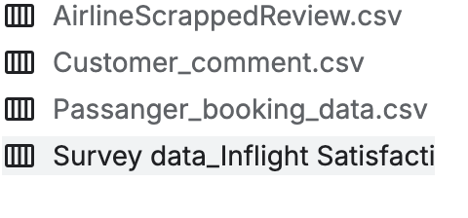

Project title: Airline Customer Holiday Booking Dataset

Data

Source: British Airways

source:https://www.kaggle.com/datasets/manishkumar7432698/airline-passangers-booking-data?select=Passanger_booking_data.csv

Motivation: nowadays, we almost face booking flight tickets, whatever in traveling, studying abroad or doing business. So as an international student, I wanna figure out customer preference and patterns of booking in the Airline industry during the holiday period as a way to plan well ahead of every holiday coming then cost-effectively book tickets. What those factors will influence customers' decisions, what the customers worry and care about. For airline companies, how to improve customer conversion rate of booking. Also, we will dive into analyzing those factors that are significant for customer satisfaction.